What Factors Affect The Rate Of A Reaction?

The four main factors that affect the rate of chemical reactions are:

* temperature,
* concentration,
* surface area,
* presence of a catalyst

**Temperature**

Temperature refers to how fast the particles in a substance are moving.

* The higher the temperature, the faster the rates of reaction, as the particles collide harder and more often.

Example:

* Food will “spoil” a lot faster out of the fridge.
* Food cooks faster in a hotter oven

**Concentration**

Refers to how much solute (solid) is dissolved in a solution (liquid).

* If a greater concentration the higher reaction rate as there are more particles to collide.

Example:

* Concentrated acid reacts quicker than a dilute acid

**Surface Area**

Refers to how much area is exposed on the surface of the object.

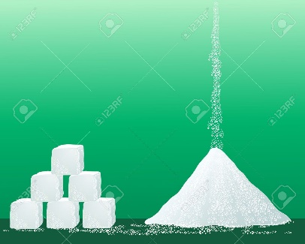The greater the surface area, the faster the reaction, this is due to more contact between the chemicals.

Example:

* Sugar cube dissolves slower than granulated sugar

**Catalyst**

* Refers to any substance that speeds up the rate of a chemical reaction without being used up in the reaction itself.

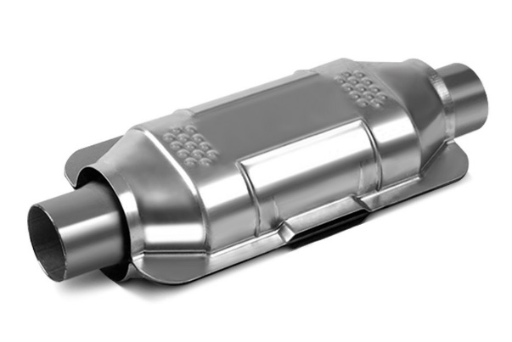Example:

* enzymes in the body
* chlorophyll in photosynthesis
* catalytic converter